**CRM Application for Jewel Management - (Admin)**

->Salesforce:

Creating Developer Account:

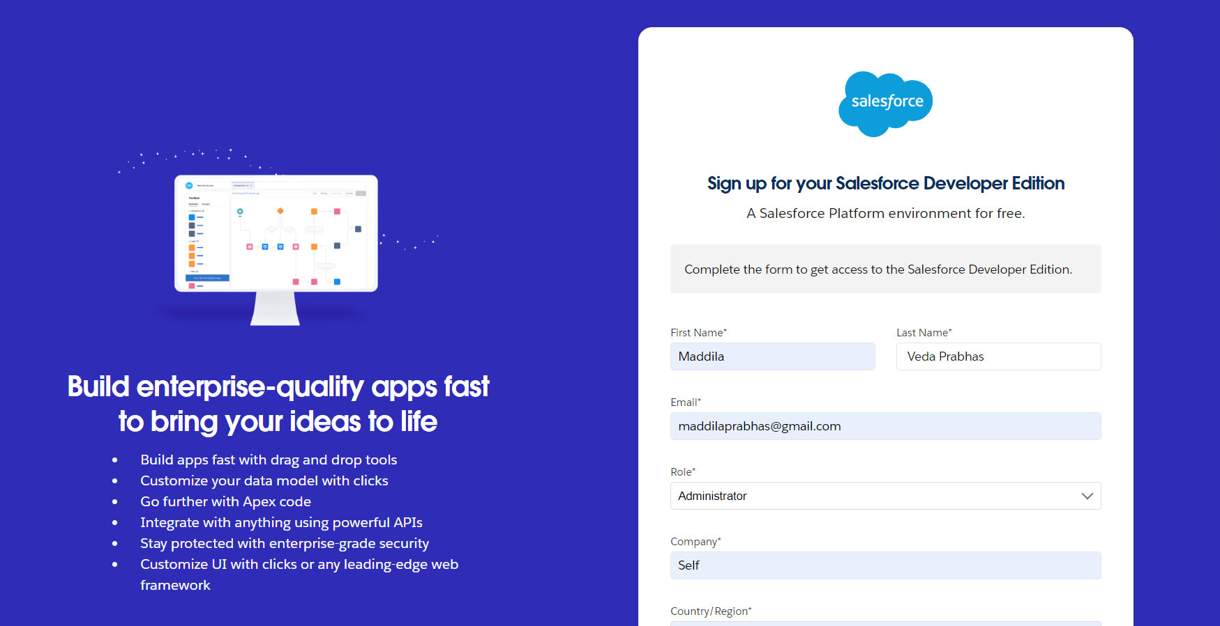

Account activation:

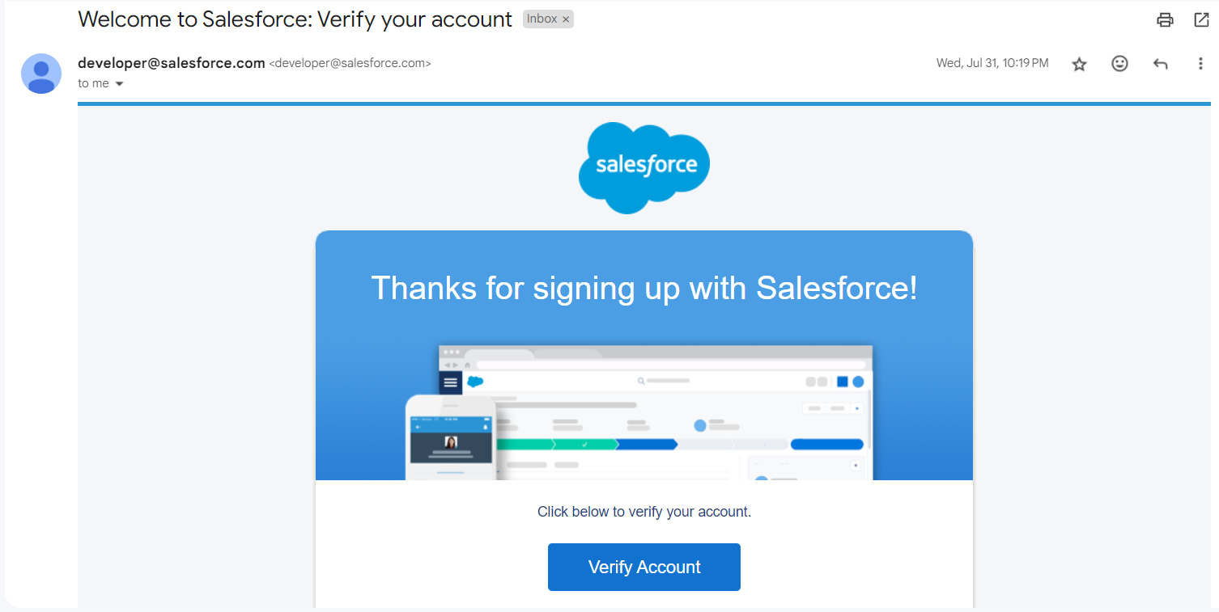

->Object:

Create a jewel Customer object:

The purpose of creating a Jewel Customer custom object is to store and manage information about Customer.

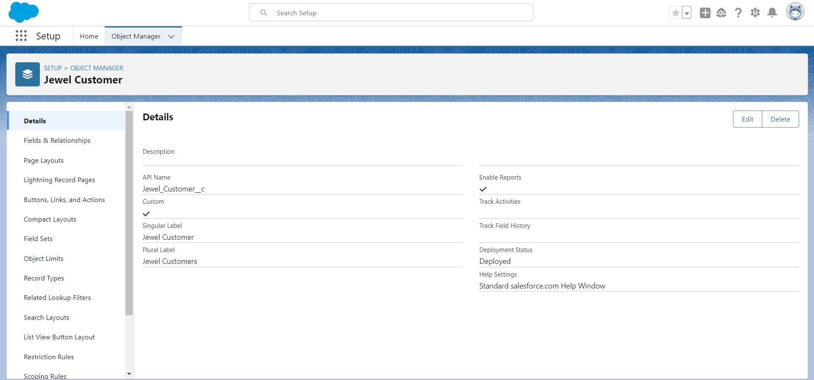

Create Item Object:

The purpose of creating a Item object is to manage the inventory of gold and silver items.

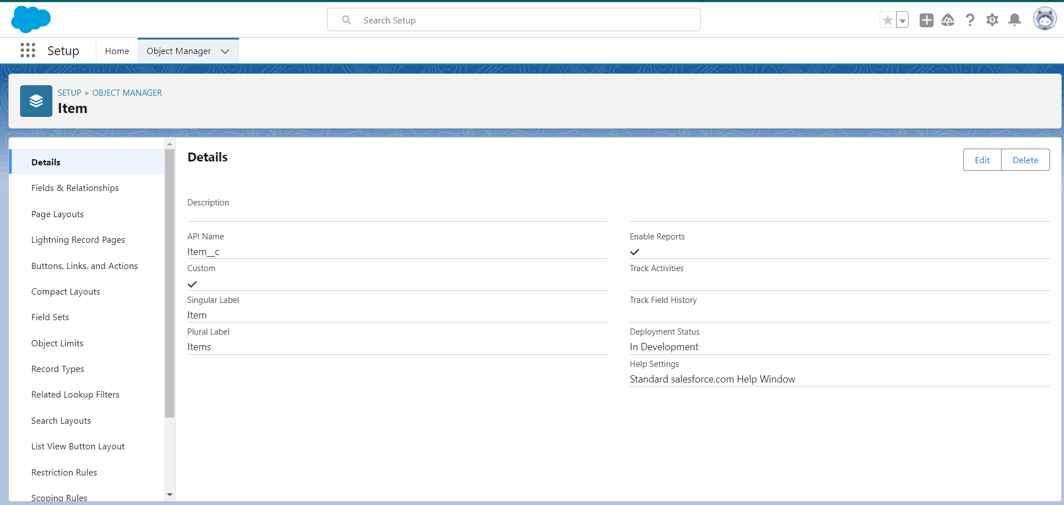

->Tabs

To Create a tab(item)

1. Go to setup page >> type Tabs in Quick Find bar >> click on tabs >> New (under custom object tab)
2. Select Object(Item) >> Select the tab style >> Next (Add to profiles page) keep it as default >> Next (Add to Custom App) keep it as default >> Save.

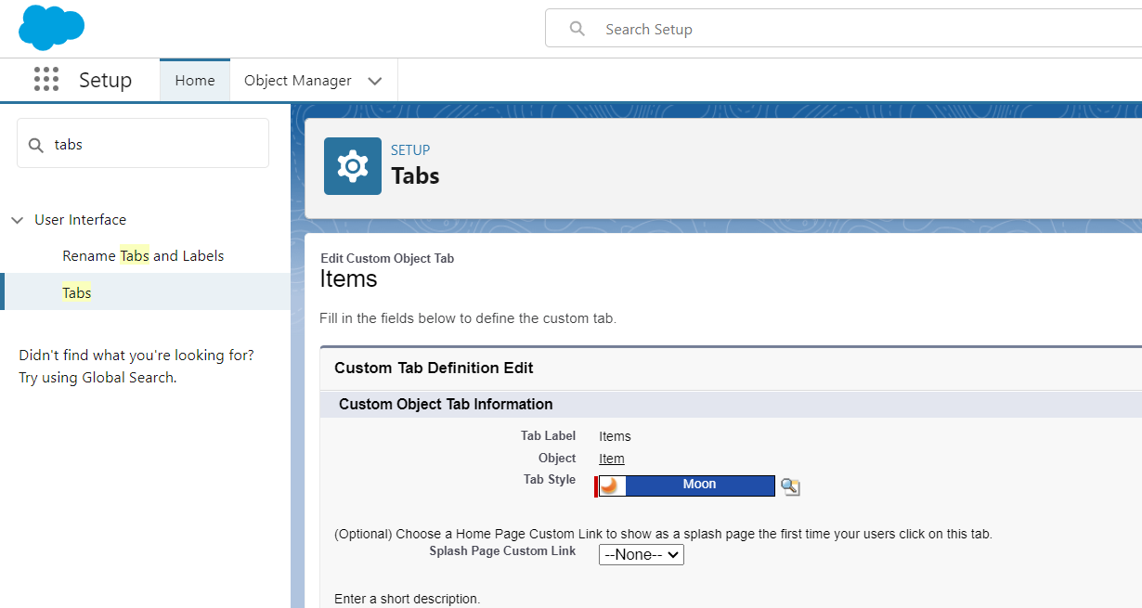

3.create tabs for Customer Order, Price, Billing objects.

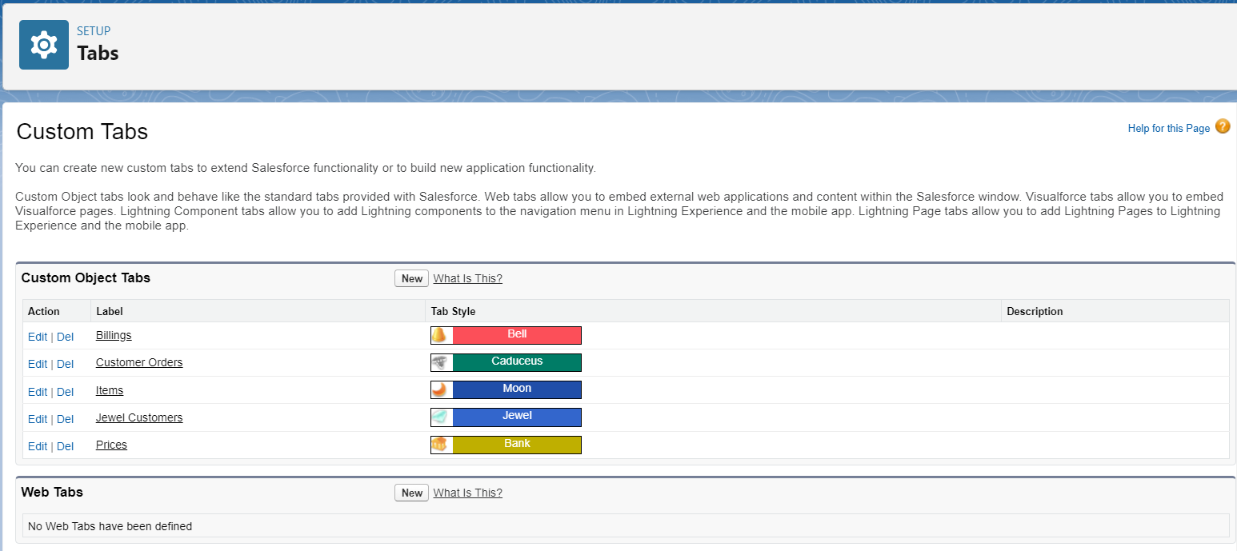

->Lightning App

Create a Lightning App:

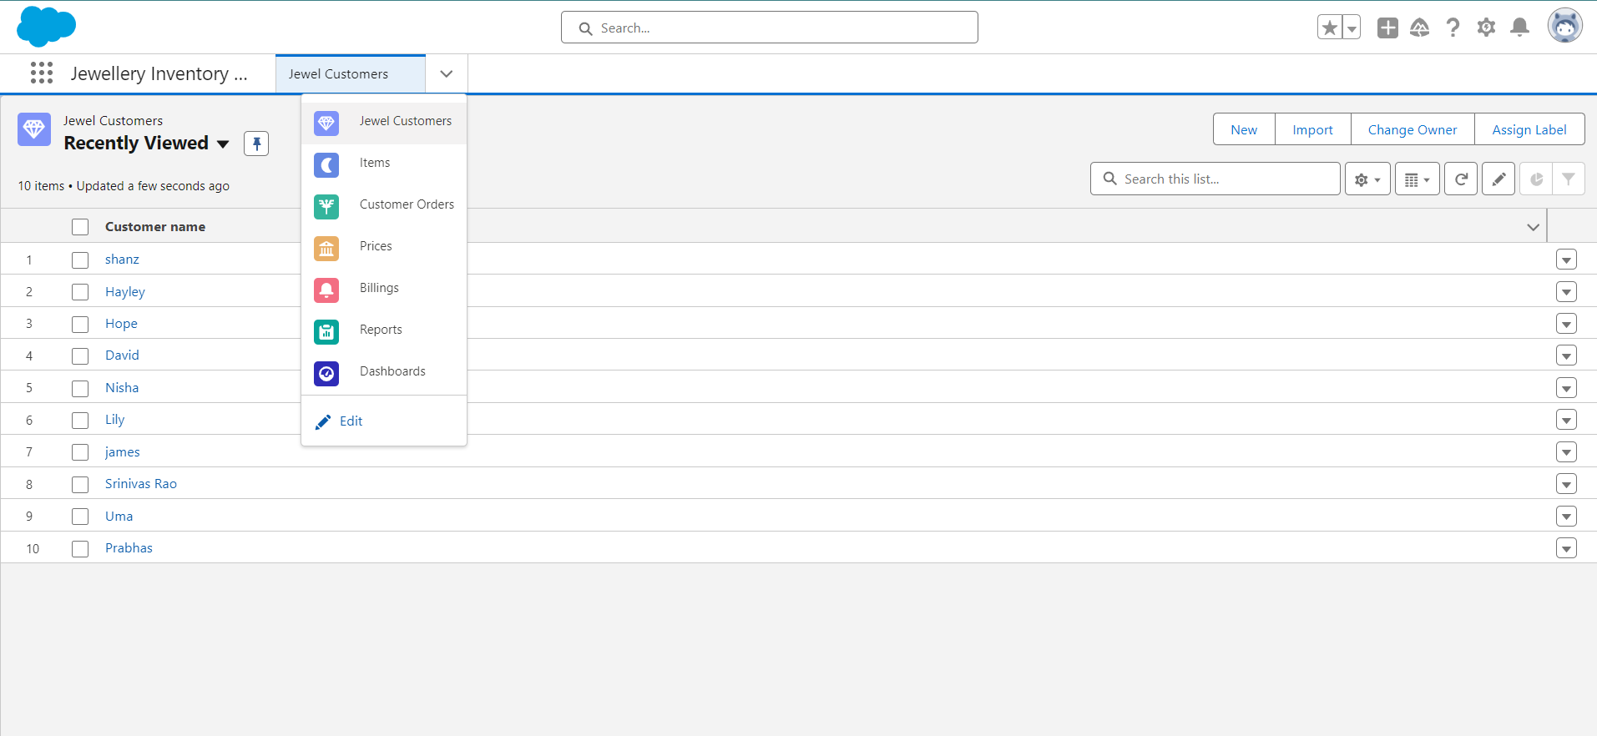

->Fields

Creating Lookup Relationship:

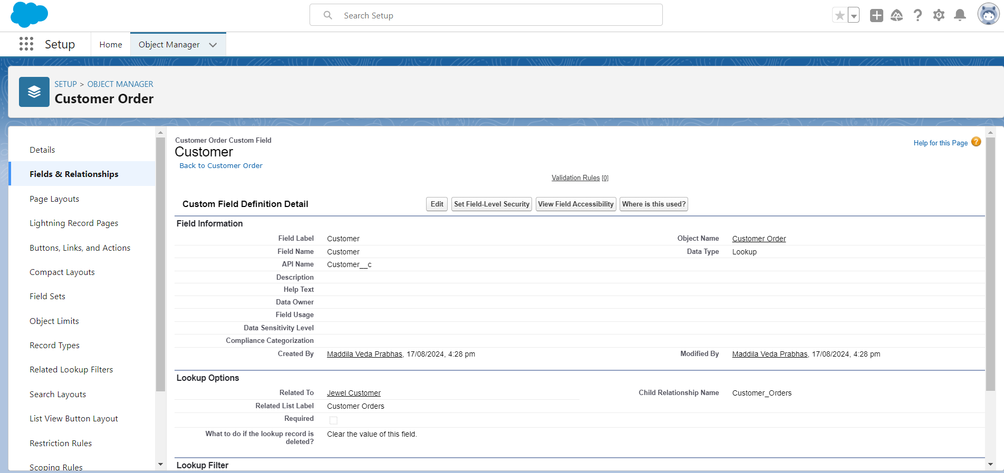

Creating a Master Detail Relationship:

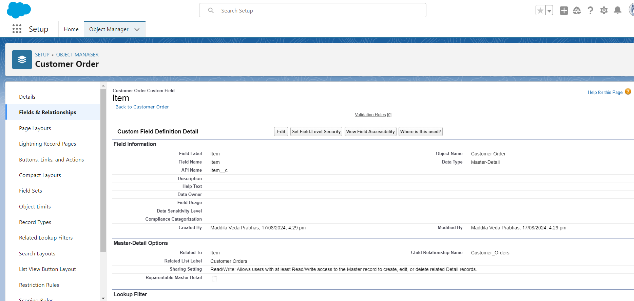

### Creating Text Field in Jewel Customer Object:

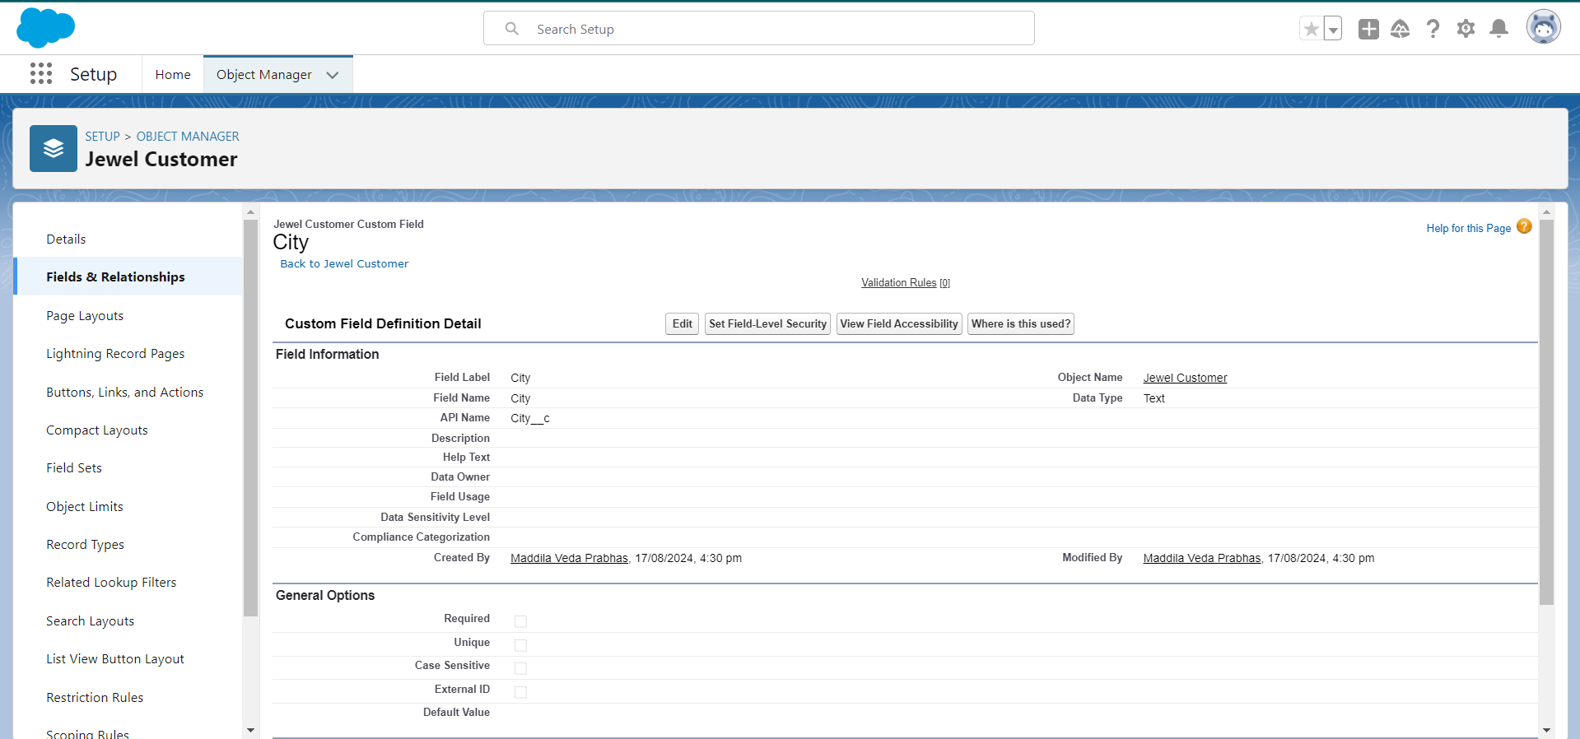

### Creating the Phone field in object Jewel Customer:

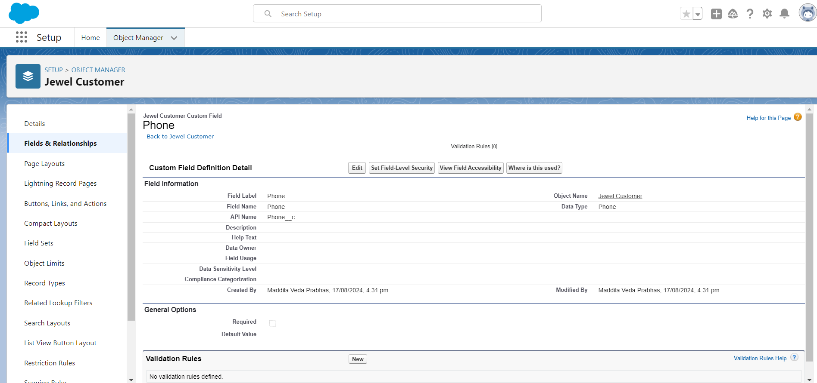

### Creating the Email field in object Jewel Customer:

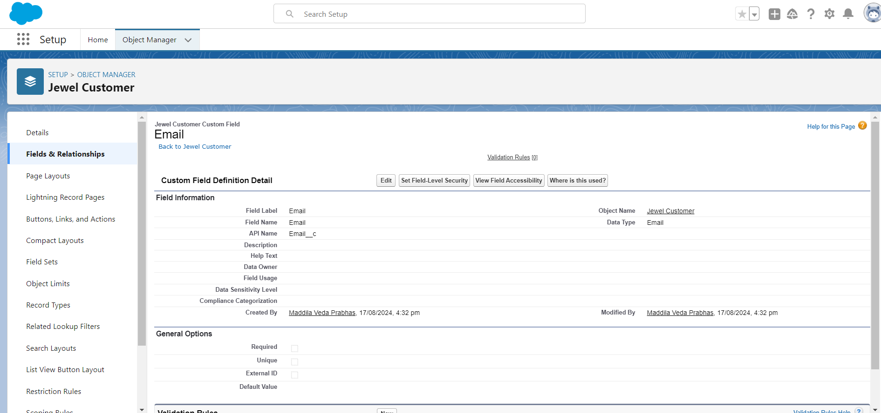

### Creating the number field in Item object:

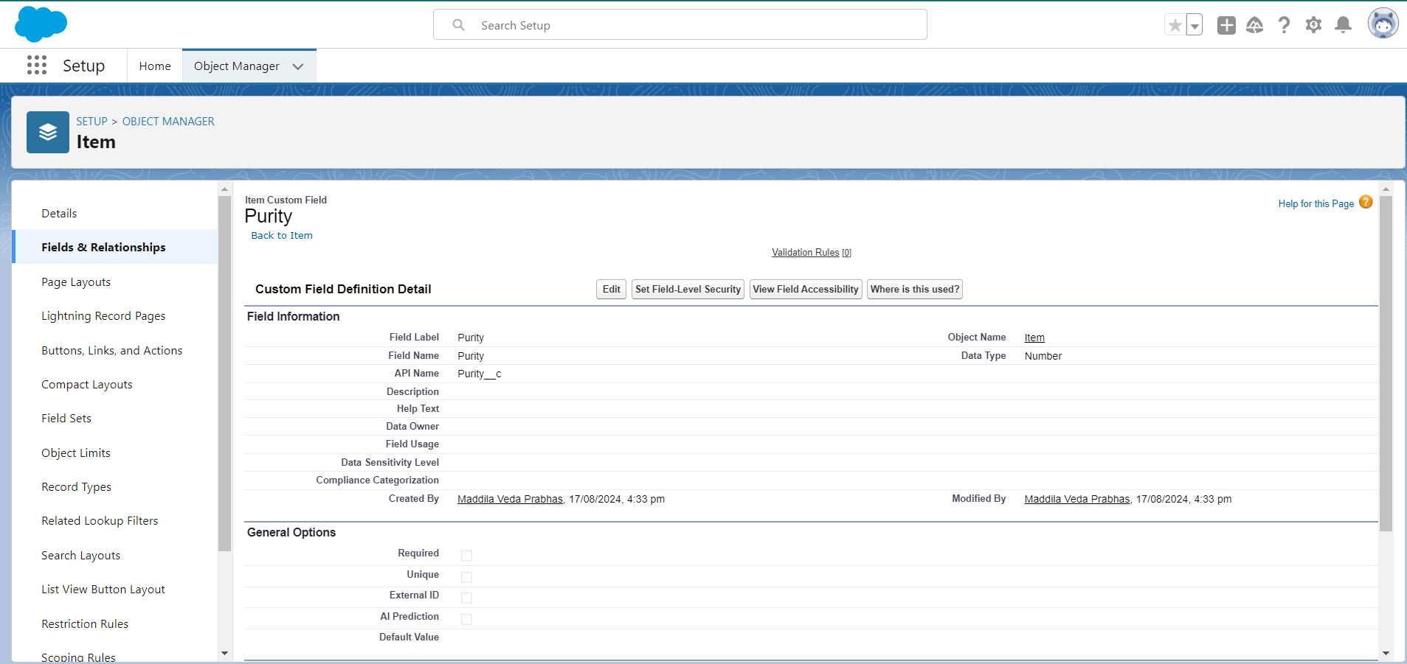

### Creating Picklist Field in Item Object:

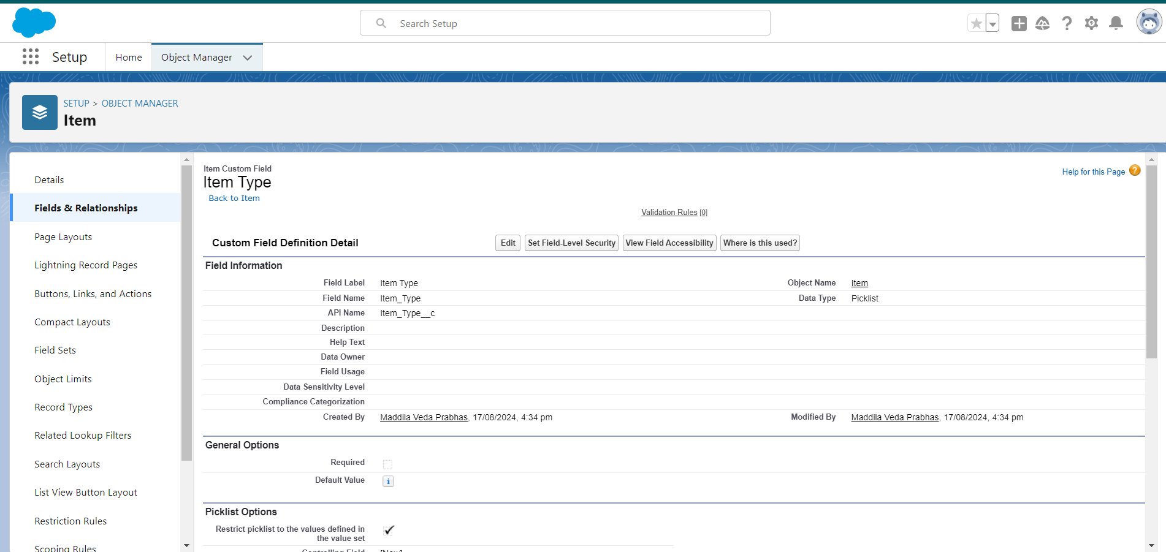

### Creating Currency Field in Price Object:

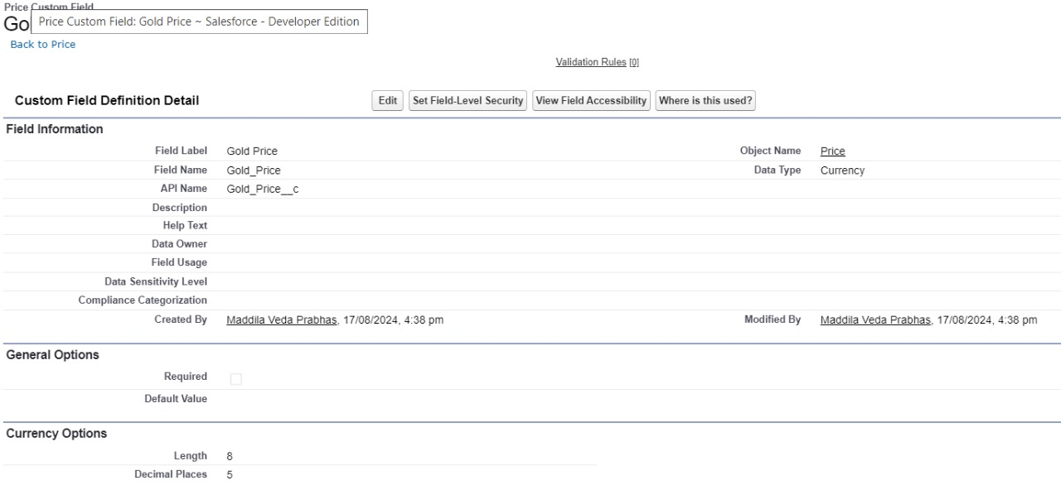

### Creating Formula Field(Cross Object) in Item Object:

### 

### Creating Remaining Fields in Objects:

Jewel Customer:State,Street,Country,Postal code.

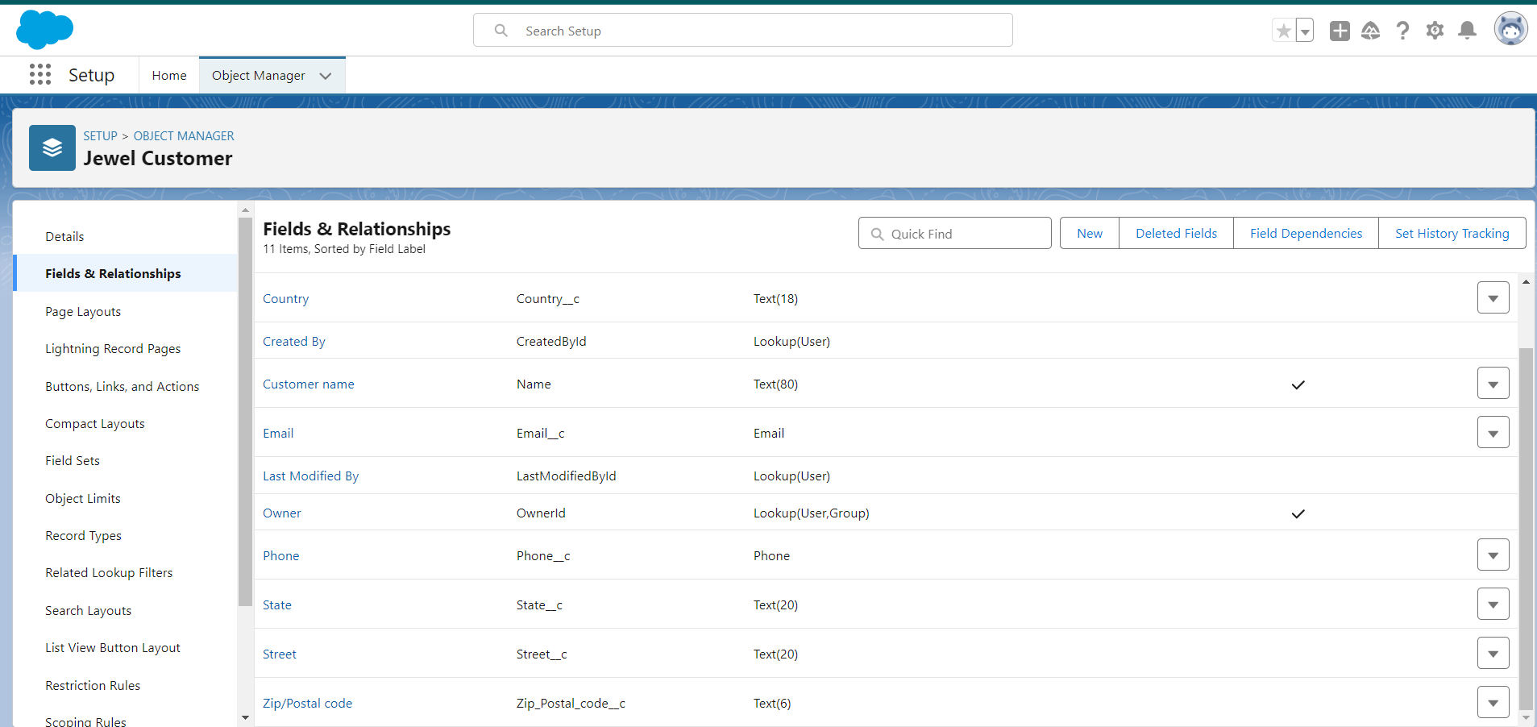

Price:Silver Price

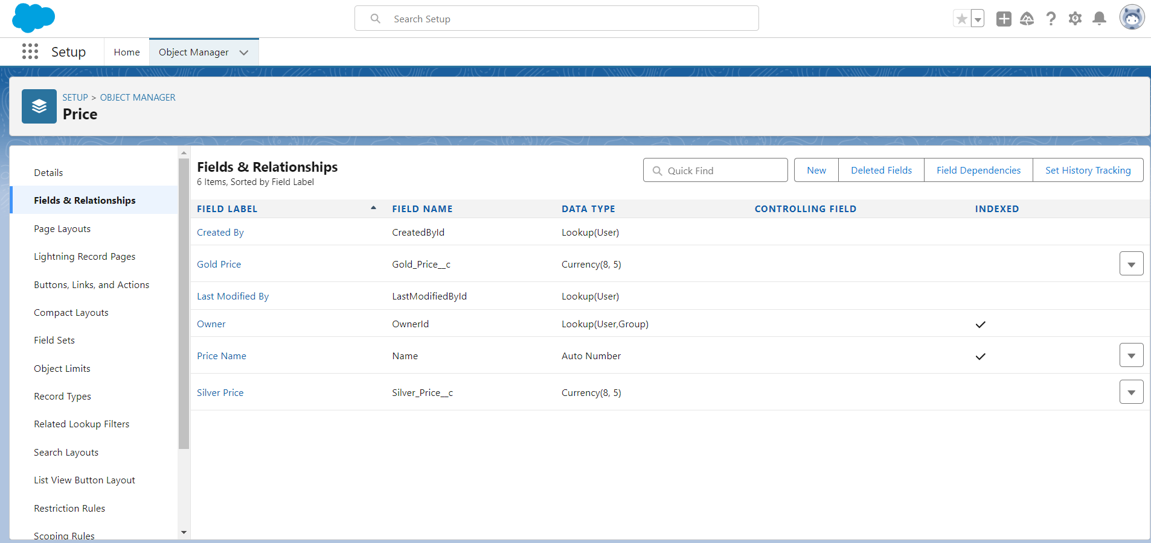

item:

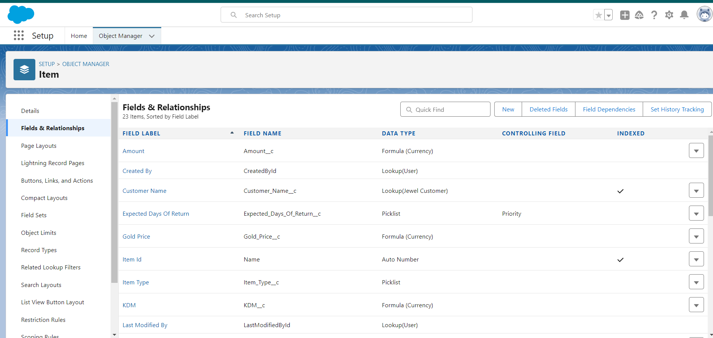

Customer Order:

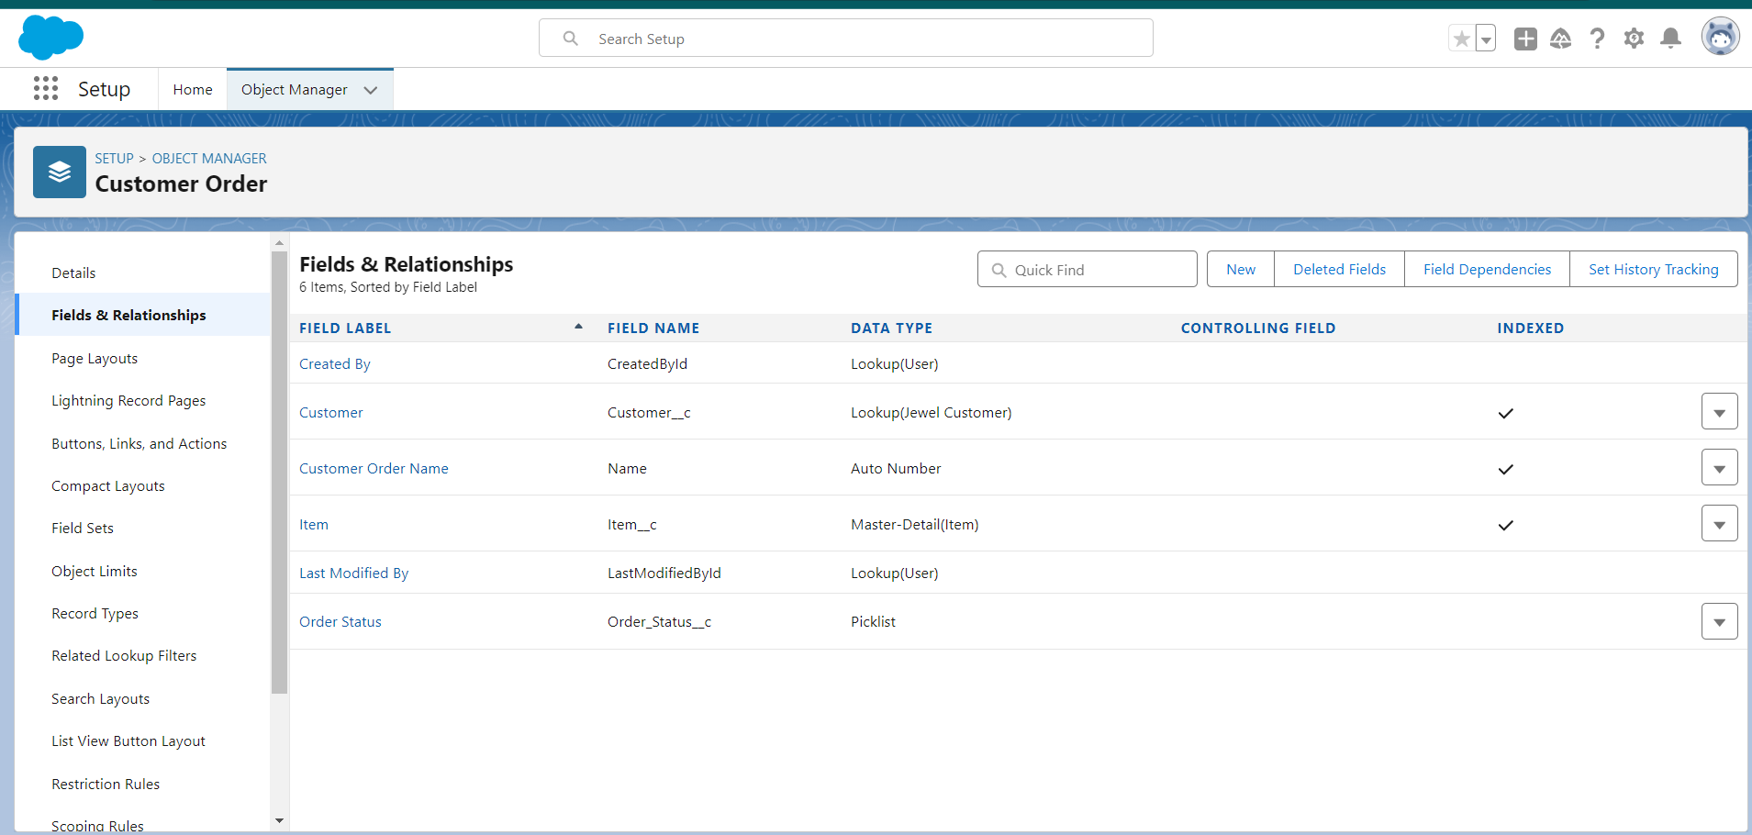

Billing:

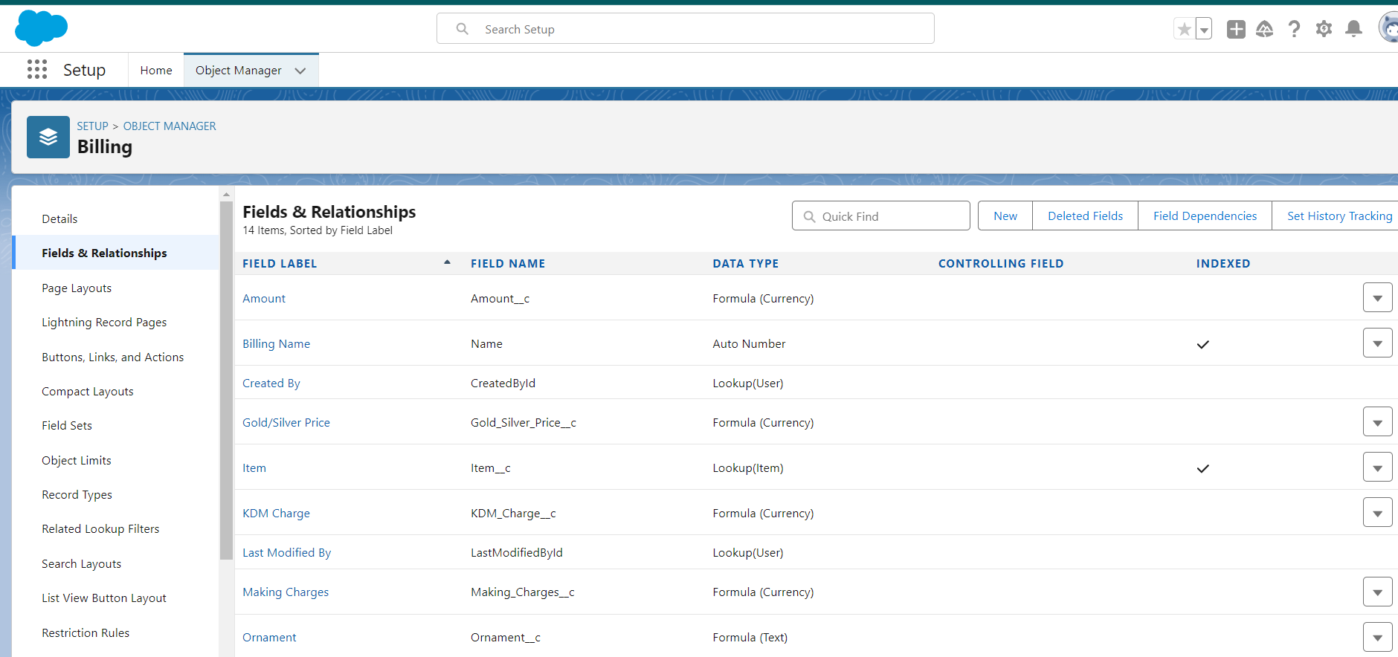

Schema Builder:

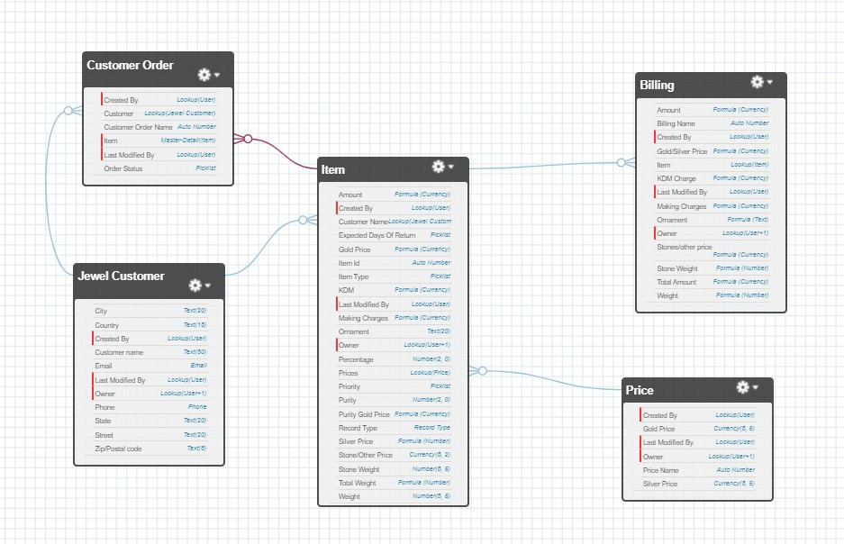

### Creating the Field Dependencies:

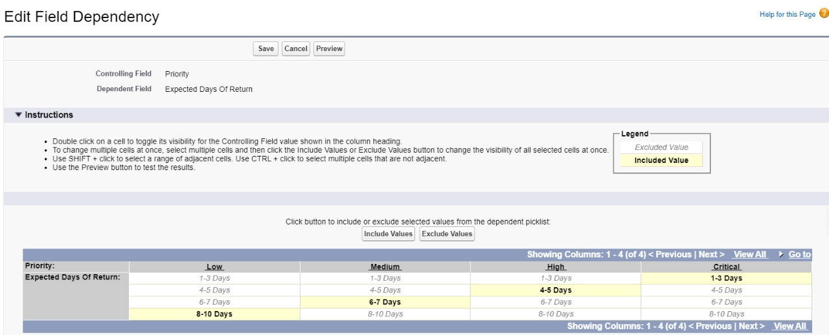

### Creating the validation rule:

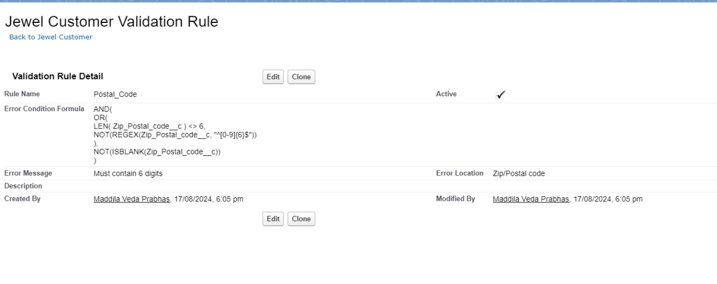

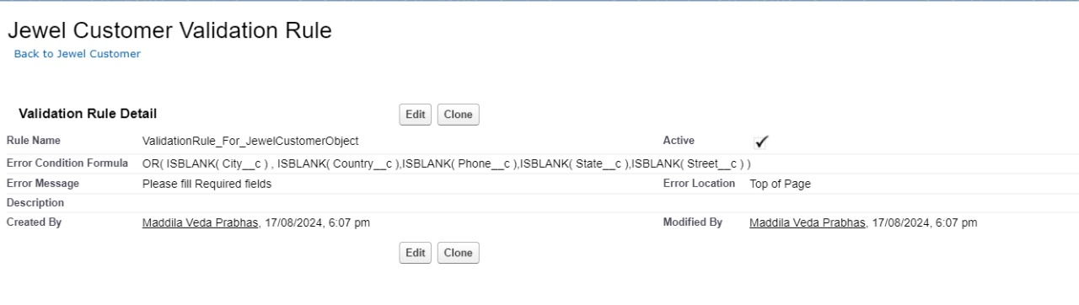

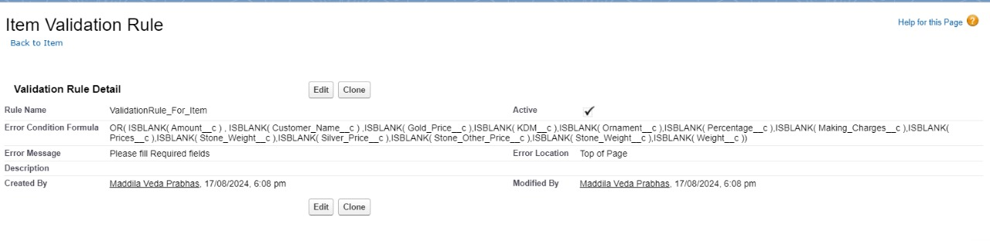

->Profiles:

Goldsmith Profile:

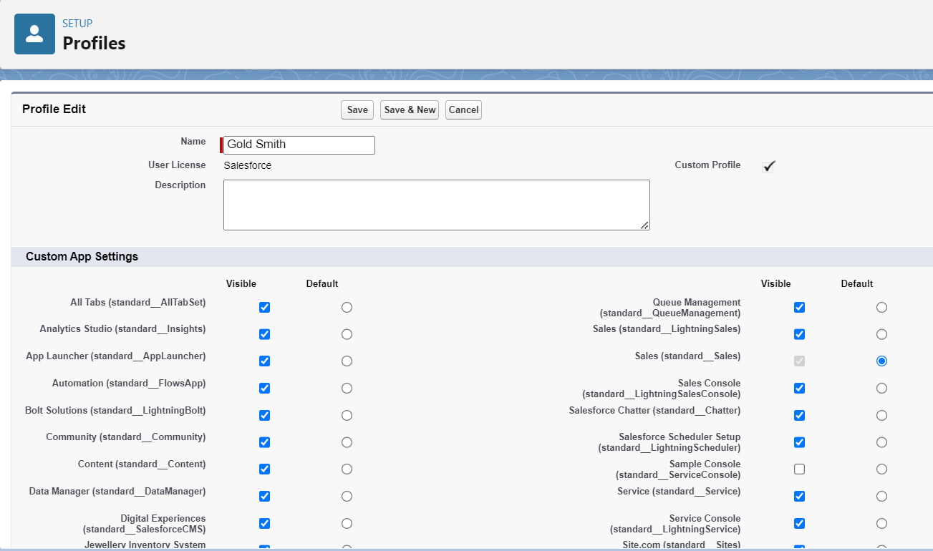

Worker Profile:

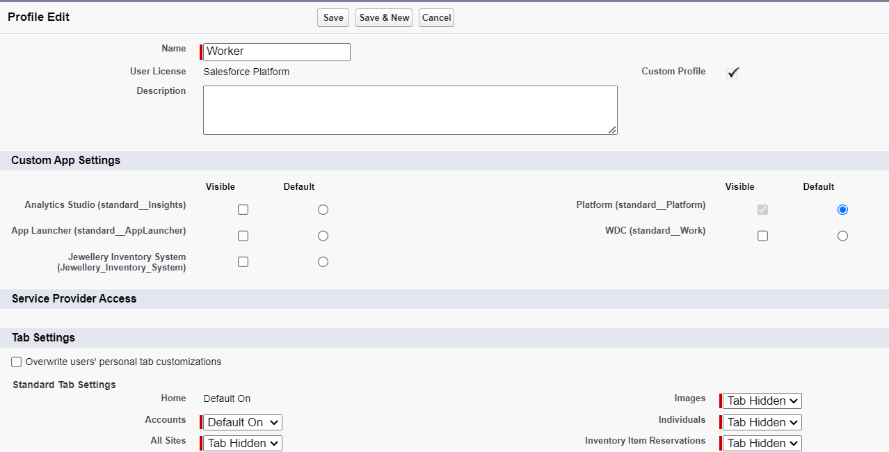

Roles:

A role in Salesforce defines a user's visibility access at the record level. Roles may be used to specify the types of access that people in your Salesforce organisation can have to data. Simply put, it describes what a user could see within the Salesforce organisation.

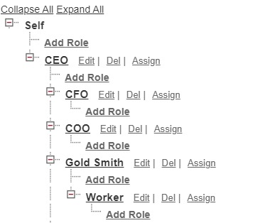

->Users:

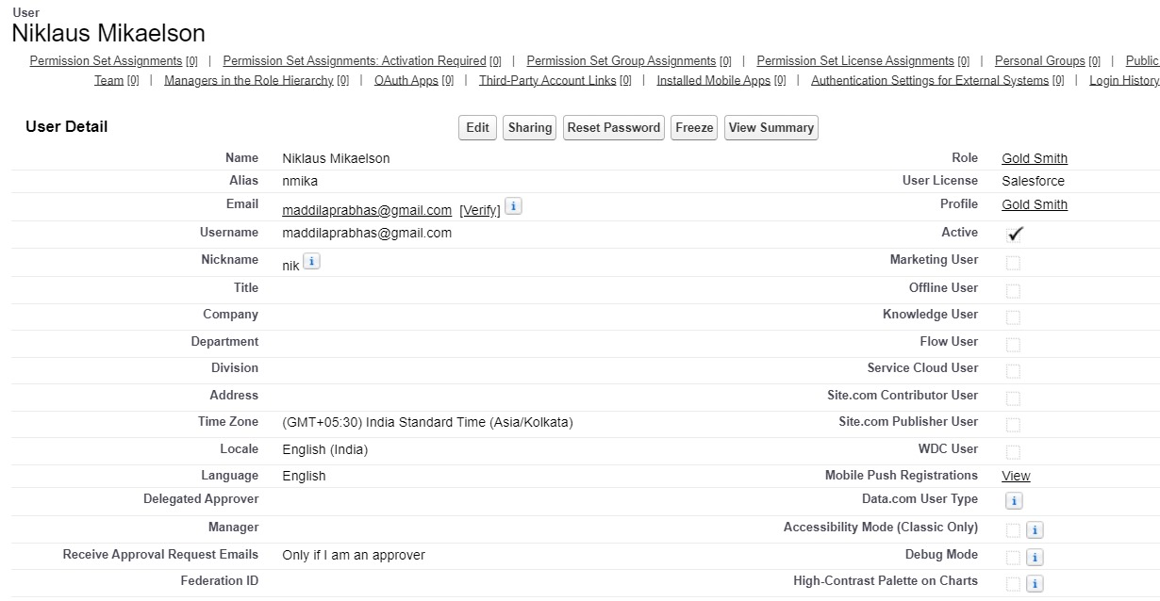

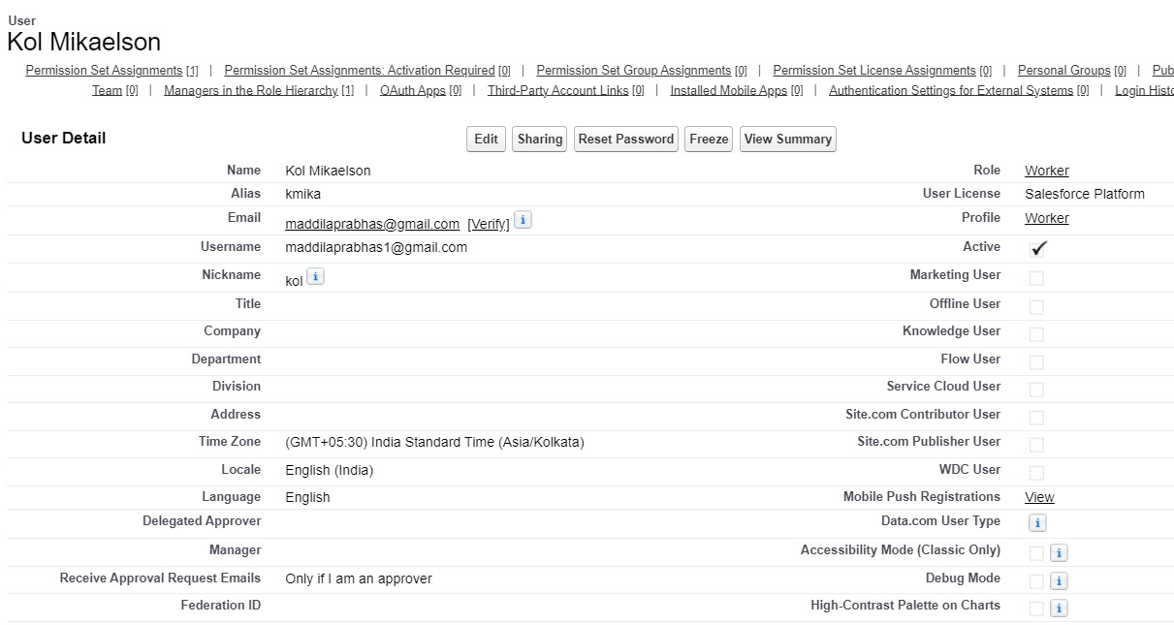

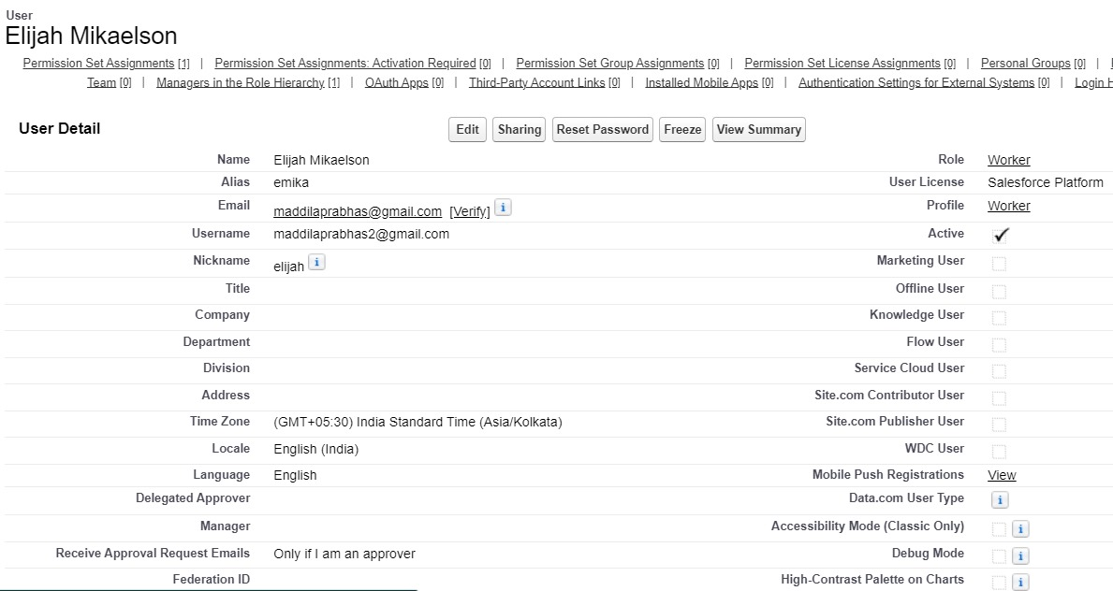

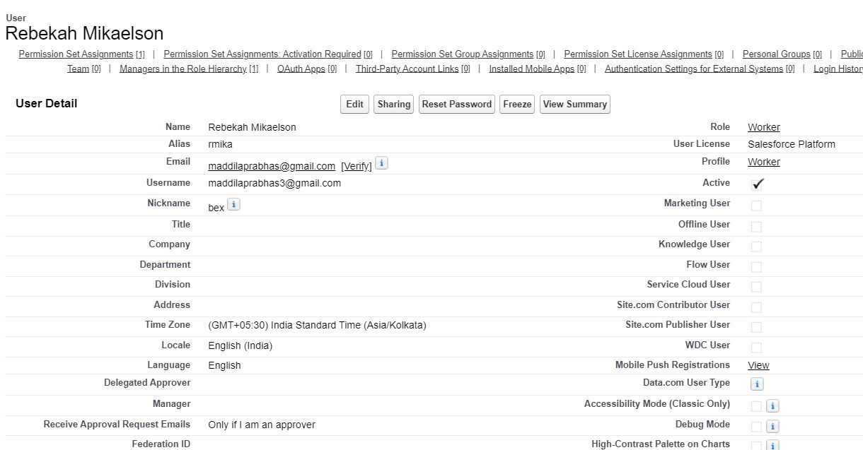

->Page Layouts:

### To Create a Gold Page layout:

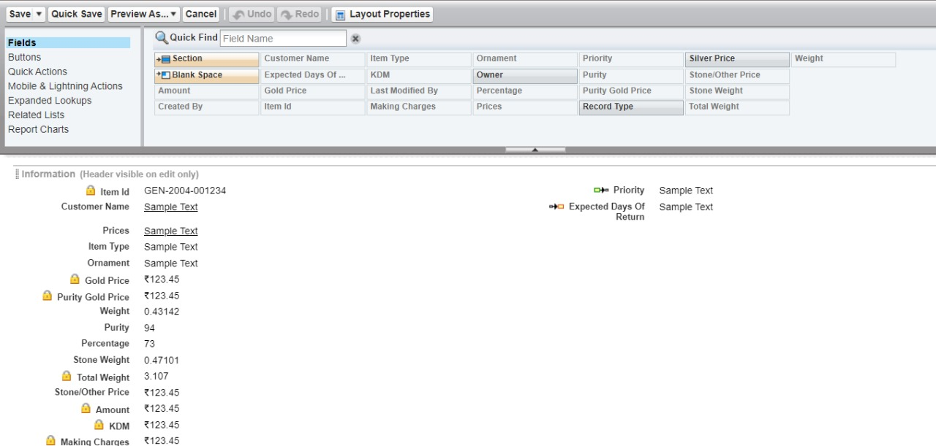

### To Create a Silver Page layout:

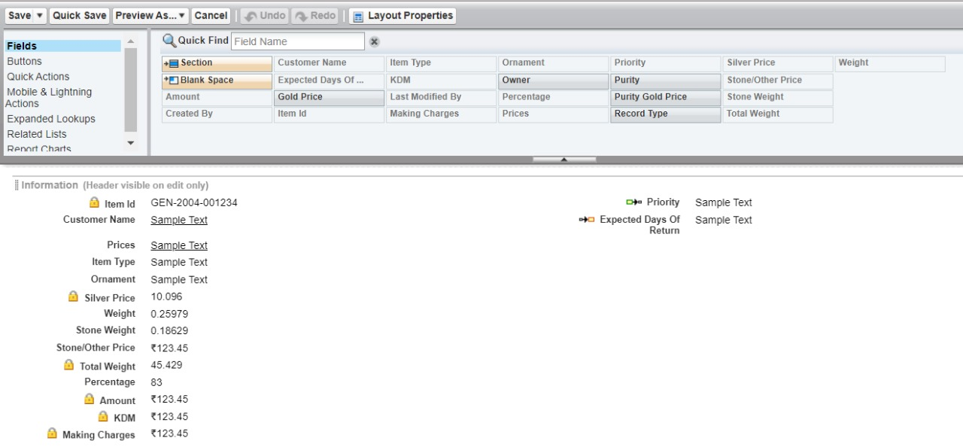

->Record Types:

### To create a Record Type:

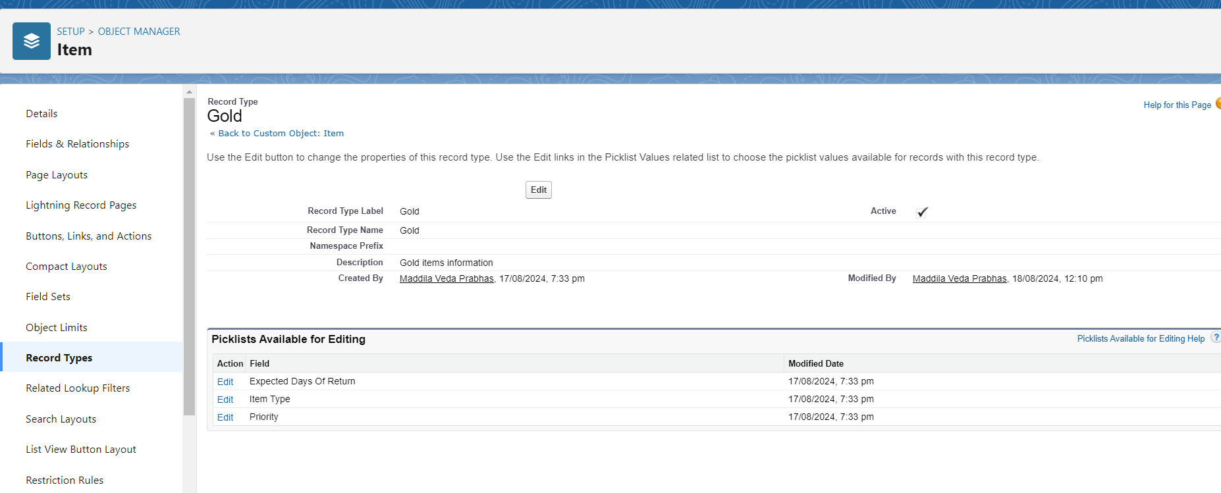

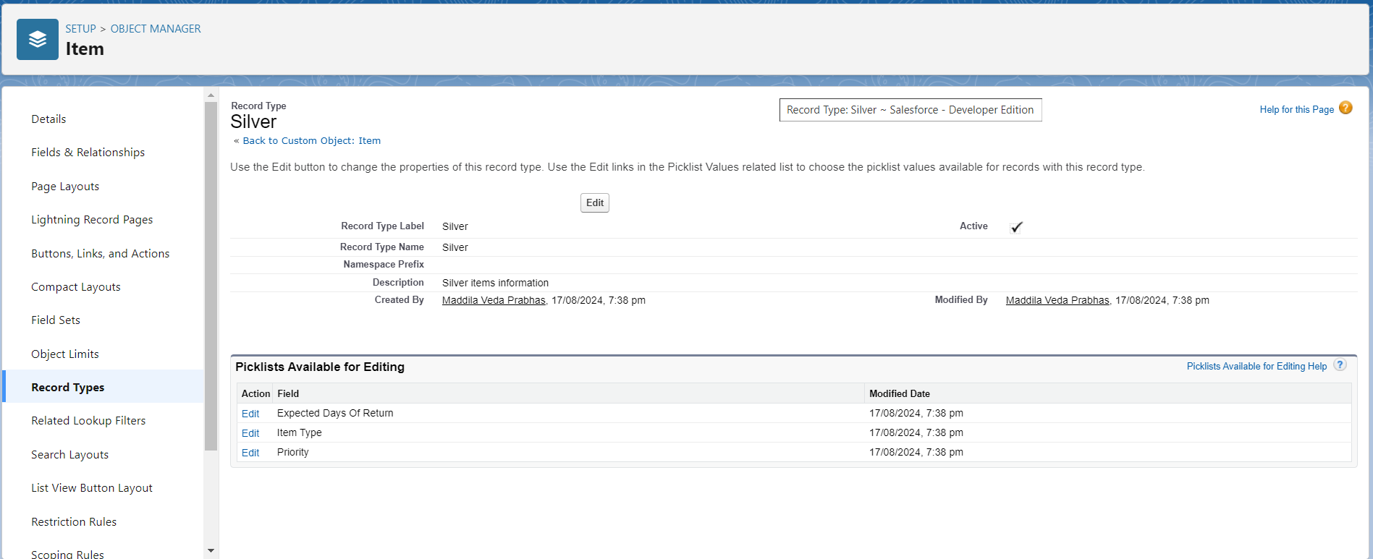

Permission Set:

Creating Permission set:

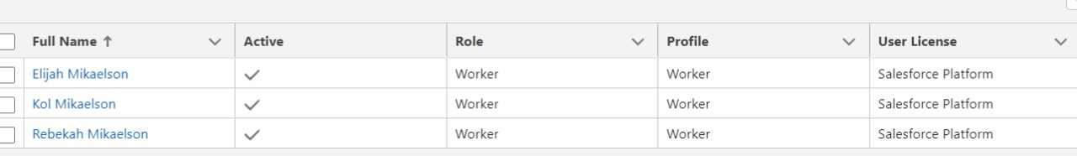

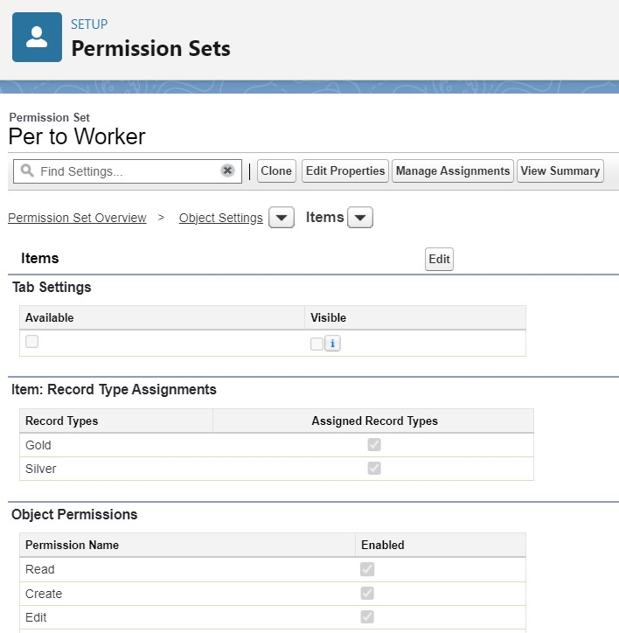

->User Adoption:creating 10 records for each

Jewel Customer:

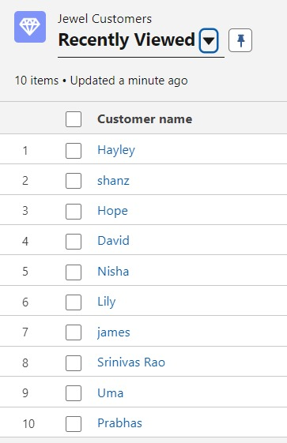

Price:

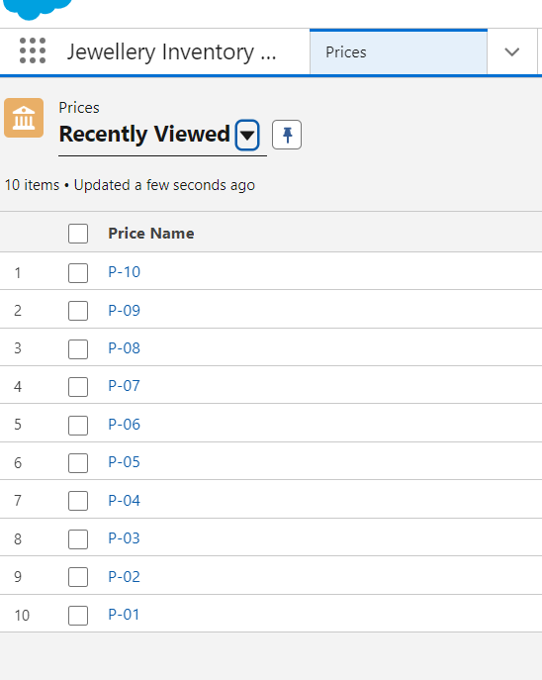

Item:

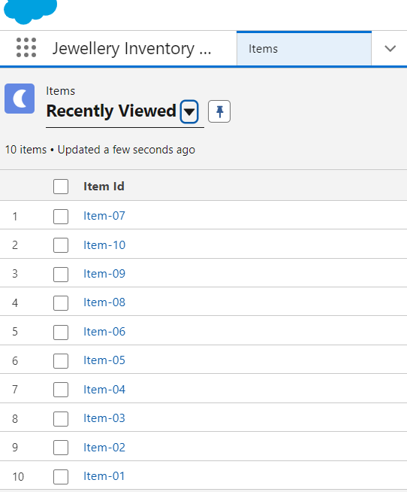

Customer Order:

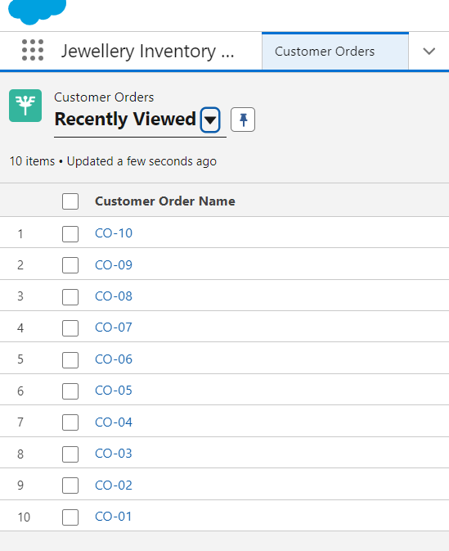

Billings:

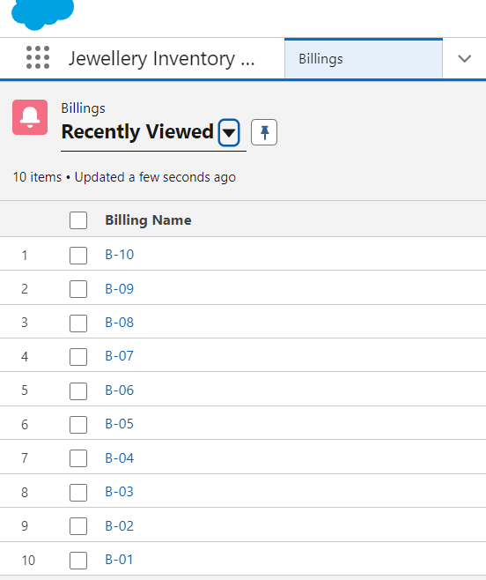

->Reports:

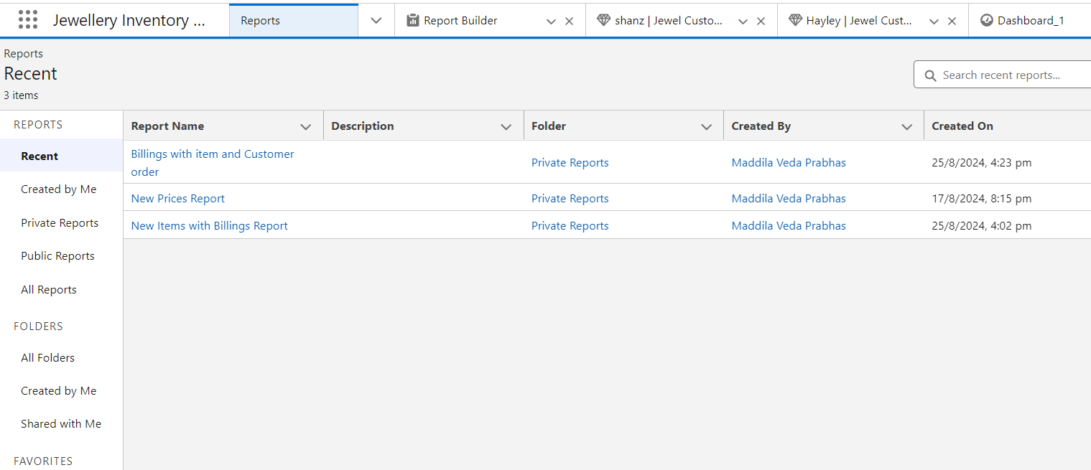

->Dashboards:

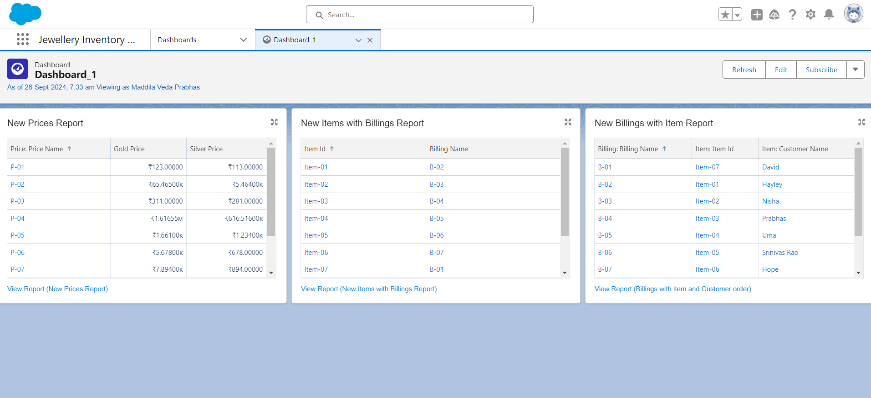

->FLow:

In Salesforce, a flow is a powerful tool that allows you to automate business processes, collect and update data, and guide users through a series of screens or steps. Flows are built using a visual interface and can be created without any coding knowledge.

